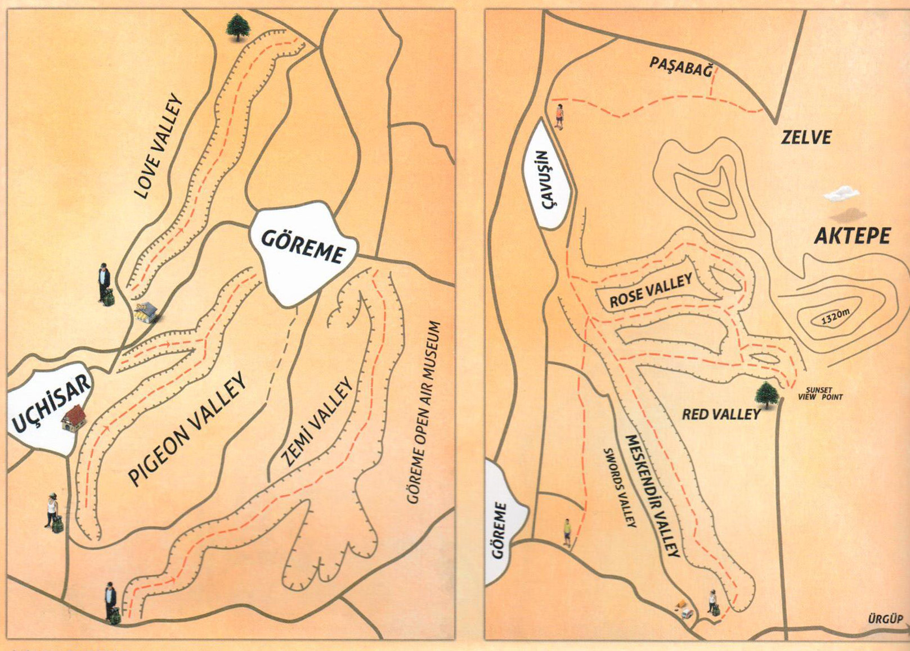
MAP OF THE GOREME NATIONAL PARK

